Advance Computer Network Assignment 1
Submitted by: Aarav Kaim

- Capture and analyze ICMP packets (Ping request and reply)
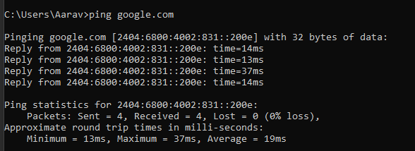

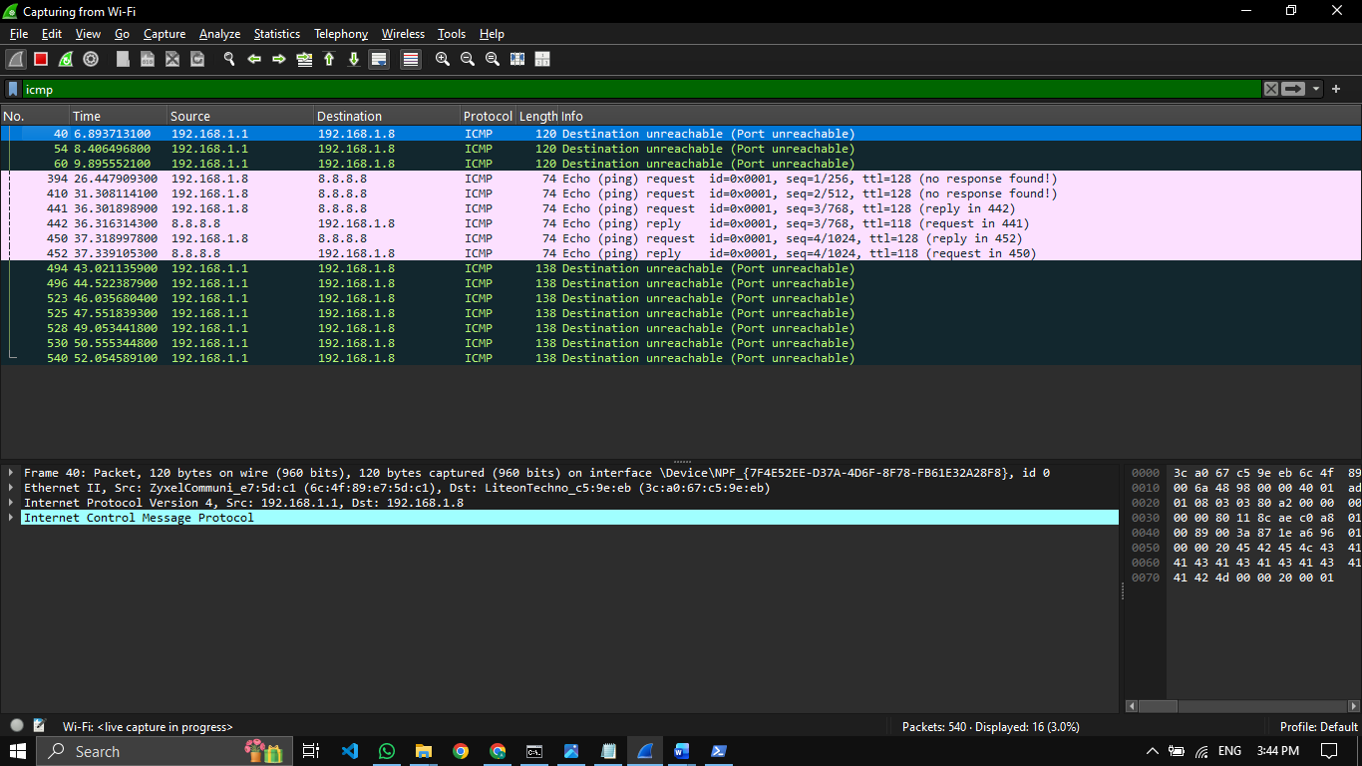
Protocol: ICMP
Source: 192.168.1.8
Destination: 8.8.8.8
Packet length: 74 bytes
ICMP packets observed:
- Echo Request
- Echo Reply
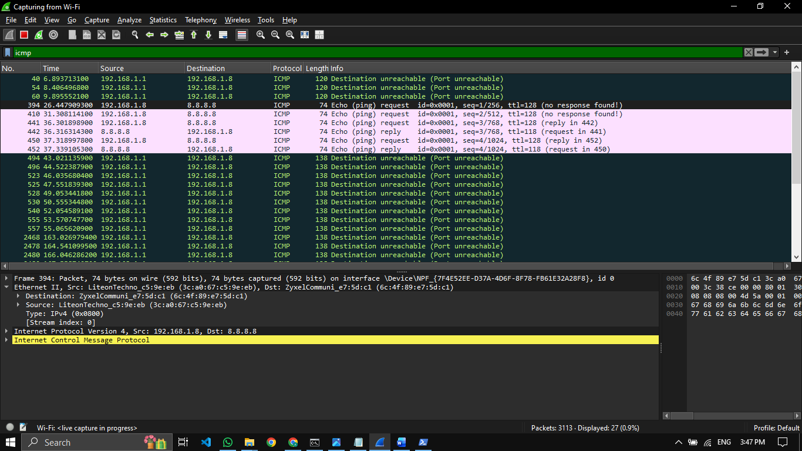

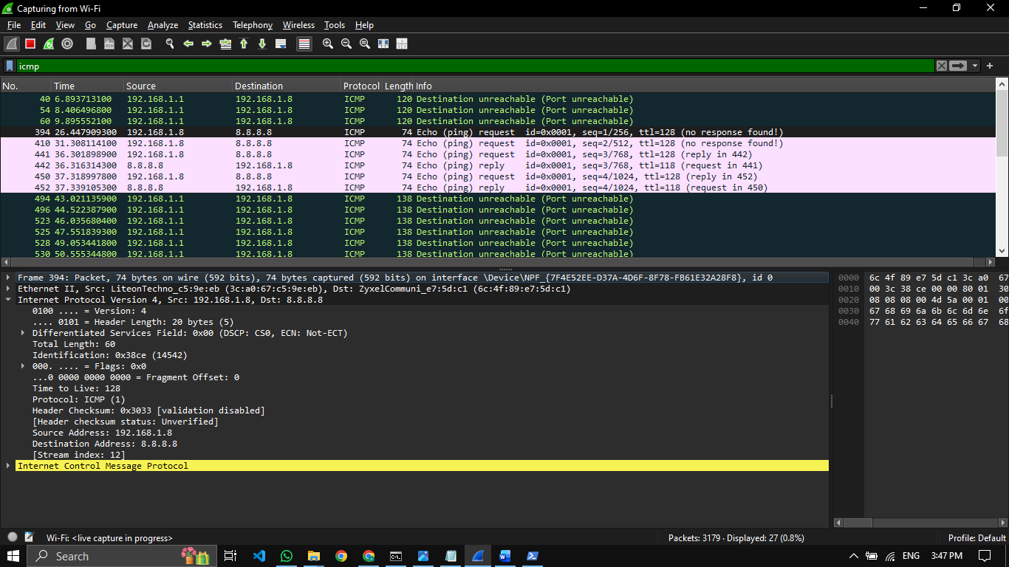

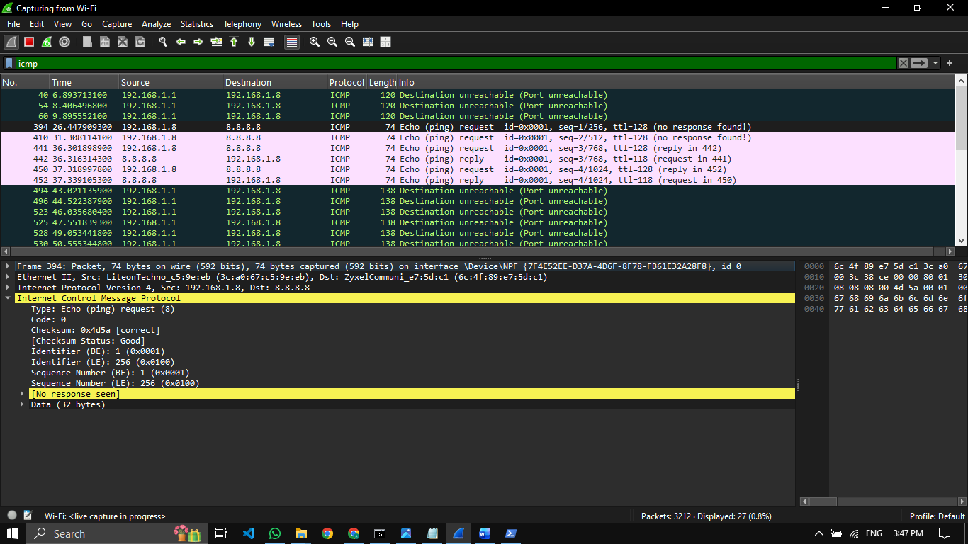

- Analyze TCP packets and observe the TCP three-way handshake
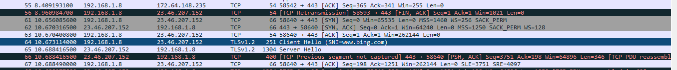
TCP Three-Way Handshake:
- Client sends SYN to initiate connection.
- Server replies SYN-ACK acknowledging request.
- Client sends ACK and connection is established.

Source IP: 192.168.1.8
Destination IP: 23.46.207.152
Source Port: 58640
Destination Port: 80 (HTTP)

- Capture and analyze UDP packets

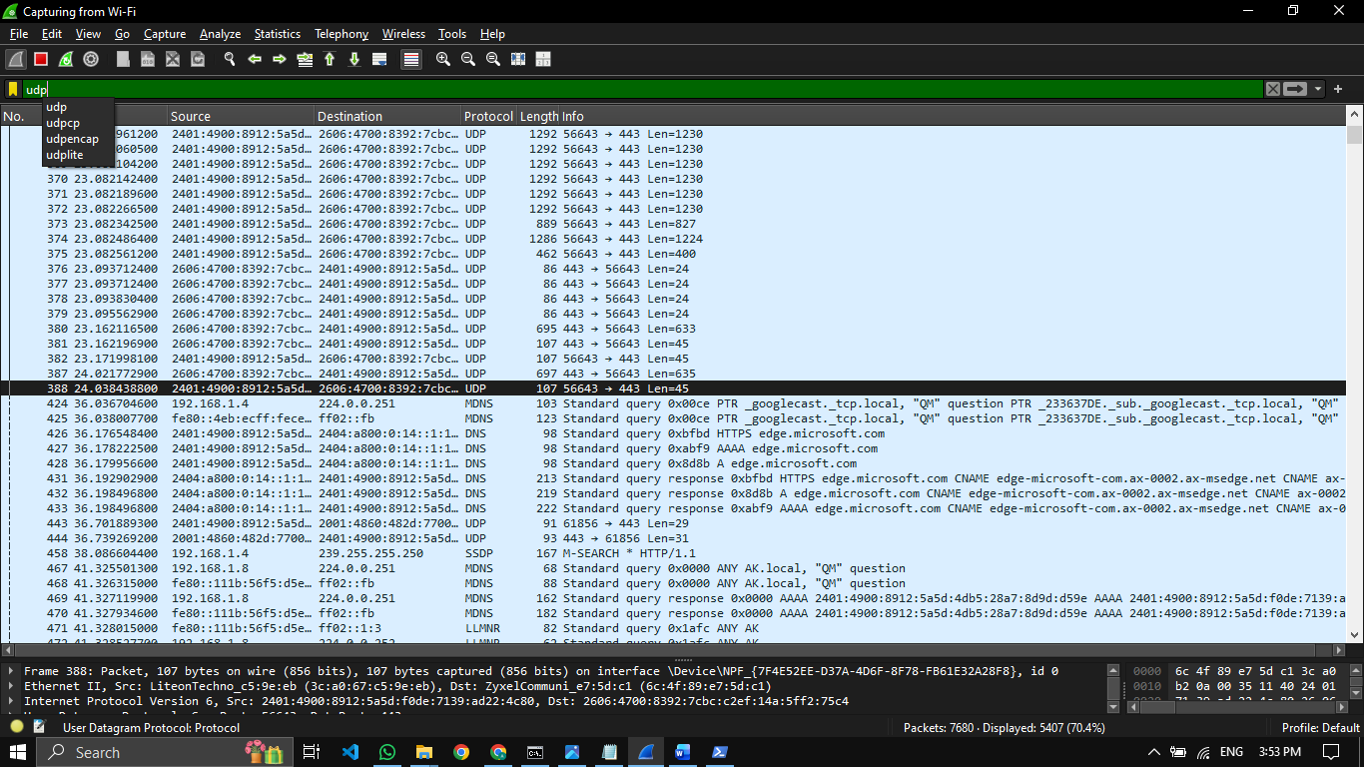

Protocol: UDP
Source Port: 56643
Destination Port: 443

- Capture and analyze DNS query and response packets

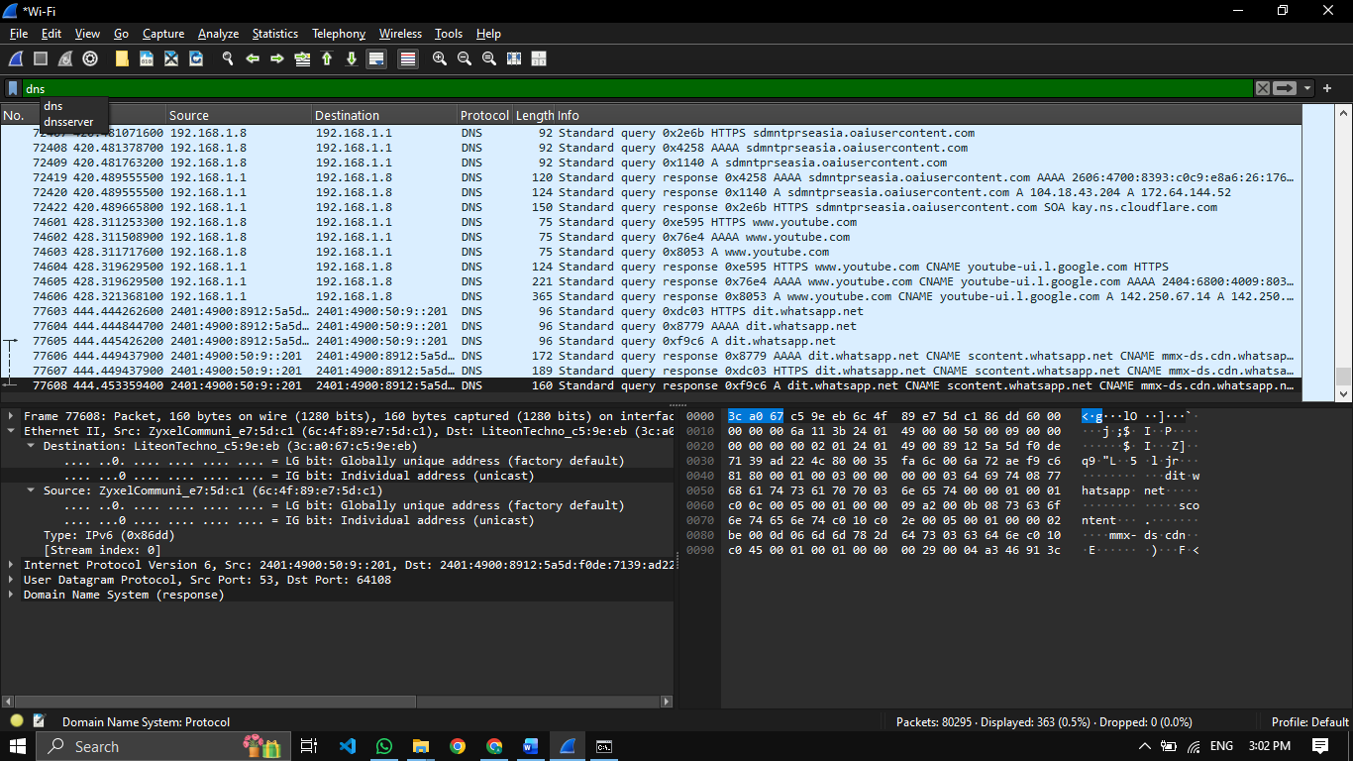

- Capture and analyze HTTP packets

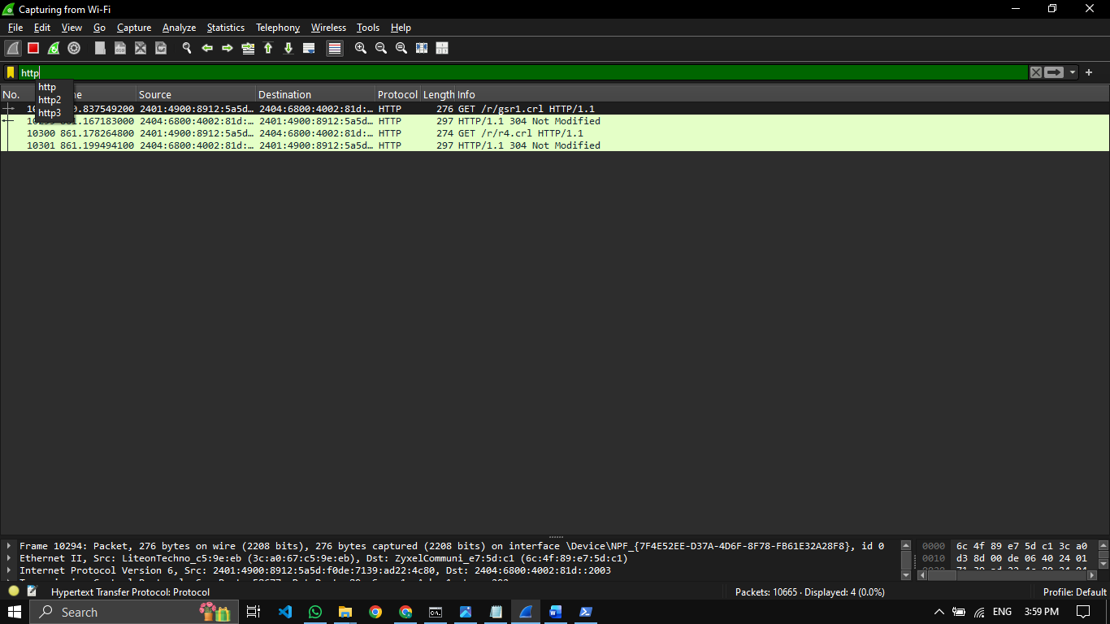

- Analyze ARP request and reply packets

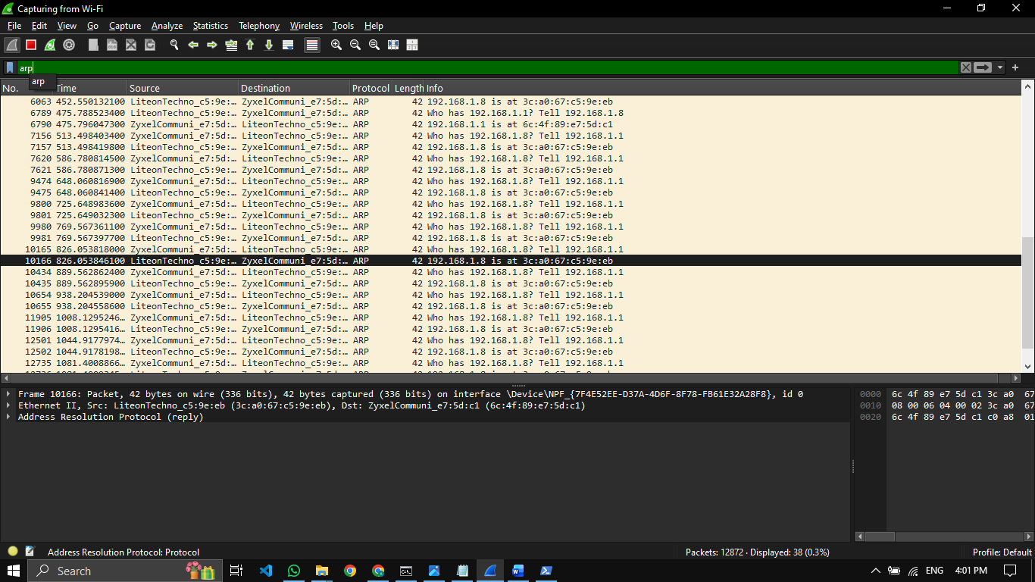

ARP Request
Sender asks:
Who has 192.168.1.8?
ARP Reply
Response gives MAC mapping:
192.168.1.8 is at 3c:a0:67:c5:9e:eb

- Identify source and destination MAC and IP addresses in captured packets
MAC Addresses
- Source MAC: ZyxelCommuni_e7:5d:c1
- Destination MAC: LiteonTechno_c5:9e:eb
IP Addresses
- Source IP: 192.168.1.1
- Destination IP: 192.168.1.8

